MA684 HW from Class 6
Linear Regression with Categorical Predictors
Hongbo Xue

1. (No compter work needed) Based on a study of maternal behavior during pregnancy, headed by Dr. Debbie Frank. We’re interested in the association between maternal alcohol use during pregnancy and pregnancy outcome. We’ll focus on B=birth weight, with higher birth weight generally reflecting a healthier pregnancy. A sample of 247 pregnant women were enrolled and followed during pregnancy. Alcohol use during pregnancy was coded as no use, lighter use, and heavier use. Control variables known to be associated with birth weight are gestational age, infant sex, and maternal pre-pregnancy weight.

Models A and B represent two different versions of a multiple regression predicting birth weight. In both Model A and B, two dummy variables were created to represent the three-category alcohol variable. For Model A, the dummy variable ‘lightalc’ was coded 1 for those with lighter alcohol use, 0 for others, and ‘heavyalc’ was coded 1 for those with heavy alcohol use, 0 for others. In Model B, ‘noalc’ was coded 1 for those with no alcohol use, 0 for others, and ‘heavyalc’ was coded 1 for those with heavy alcohol use, 0 for others. The ‘child sex’ variable is coded 1 for males, 0 for females.

In these analyses, birth weight is measured in grams, with a mean (sd) of 3167 (484) grams in this sample.

Both Model A and B give an identical ANOVA tables for the regression, with R²=0.26, p<0.001.

Results of multiple regression analyses predicting political awareness from age, sex, income, and political affiliation.
 | Model A
 | Slope | p-value
Model A  Intercept  Gestational age  Child Sex (Male)  Pre-preg Wt  LightAlc  HeavyAlc | -1559.1  107.6  223.5  2.5  -203.5  -301.2 | ---  <0.001  <0.001  <0.001  0.010  <0.001
Model A  Intercept  Gestational age  Child Sex (Male)  Pre-preg Wt  NoAlc  HeavyAlc | -1763  107.6  223.5  2.5  203.5  -97.7 | ---  <0.001  <0.001  <0.001  0.010  0.348

1A. Note that the slope and p-value for child sex is the same in both Model A and Model B. Give an interpretation of this slope and p-value.
Answer:
In Model A and Model B, both of them p-value are smaller than 0.05, we could say there is significant correlation between sex and birth weight.
Controlling for other variable, as increase1 male, the birth weight will increase 223.5

1B. The slopes and p-values for gestational age, child sex, and maternal pre-pregnancy weight are the same for both models, but the slopes associated with the alcohol variables (and the alcohol variables included in the model) differ for the two models. In particular, the ‘HeavyAlc’ variable has a p-value of <0.001 in Model A, but a p-value of 0.348 in Model B. Give an interpretation of the slope and p-value for HeavyAlc in Model A, and an interpretation of the slope and p-value for HeavyAlc in Model B.
Answer:
In Model A:
For HeavyAlc, as HeavyAlc increase 1, the birth weight decrease 301.2 grams. And we can find p-value<0.001. So there is significant correlation between HeavyAlc and weight.

In Model B:
For HeavyAlc, as HeavyAlc increase 1, the birth weight decrease 97.7 grams. And we can find p-value=0.348. So there is no significant correlation between HeavyAlc and weight.

1C. Using both Model A and Model B, calculate the predicted birth weight for a female child, born at 40 weeks gestation, to a mom with pre-pregnancy weight of 120 lbs, who did not drink alcohol during pregnancy. How do the predicted birth weights compare between the two versions of the regression model?
Answer:
In Model A:
Birth weight= -1559.1+40*107.6+2.5*120=-1559.1+4304+300=3044.9

In Model B:
Birth weight= -1763+40*107.6+2.5*120+203.5=3044.5
I think we should put each coefficient of variable in our formula.

1D. Both Model A and Model B give an R-square of 0.26, and an ANOVA table with SSModel of 15,042,453, and a Mean Square Error of 176,592 with 241 df.

A reduced model containing only gestational age, child sex, and pre-pregnancy weight gives an R-square of 0.21 with SSModel of 11,896,782, and a Mean Square Error of 188,084 with 243 df.

For Model A, what is the increase in R-square due to alcohol use during pregnancy? What is the partial F-test testing whether this increase in R-square is significant?
Answer:
F=[(15042453-11896782)/2]/176592=8.91
We could find the p-value smaller than 0.05, then this is a significant association between alcohols use and birth weight.

2. (Hypothetical data based on an article from the American Journal of Public Health) A study examined the association between alcohol consumption and depression. A sample of 300 adults representing the general U.S. population was surveyed. Level of depression was measured through 7 questions that asked about the frequency of depressive symptoms, and was summarized as a ‘depressive symptoms score’ that can range from 0 to 28 with higher values indicating higher levels of depressive symptoms. Data are saved in the accompanying Excel and text files.

Variables in the data set are:
1) study id number, ranging from 1 to 300;
2) sex, coded 1 for males and 0 for females;
3) race-ethnicity, coded 1 for non-Hispanic Whites, 2 for non-Hispanic Blacks, 3 for Hispanics, 4 for Asians;
4) age, in years, ranging from 21 to 65;
5) years of education, ranging from 8 to 16 in this sample (a high school graduate has 12 years of education, and 16 years indicates a college graduate);
6) marital status, coded 1 for never married, 2 for currently married/living as married, and 3 for separated/divorced/widowed;
7) alcohol consumption, measured as the number of alcoholic drinks per week over the past month, ranging from 0 to 16 in the sample;
8) depressive symptom score, ranging from 1 to 16 in this sample;
9) categorized alcohol consumption, coded as 0 for abstainers, 1 for lighter drinkers (1 to 7 drinks per week), and 2 for heavier drinkers (8 or more drinks per week);

Our focus will be on the association between alcohol consumption and depressive symptoms (note that this is a cross-sectional survey, and does not provide information about the causation/direction of any association between alcohol use and depression – does alcohol use lead to depression, or do depressed people tend to drink more?).

2A. Run a multiple regression predicting depressive symptom score from age, sex, years of education, and alcohol consumption as the number of drinks per week (variable 7). Present the results of this analysis in a table reporting the slopes, standard errors, and p-values.

How well does this regression predict depressive symptoms?

Based on this analysis, describe the association between alcohol consumption and depressive symptoms by interpreting the slope for alcohol consumption in this model.
Answer:
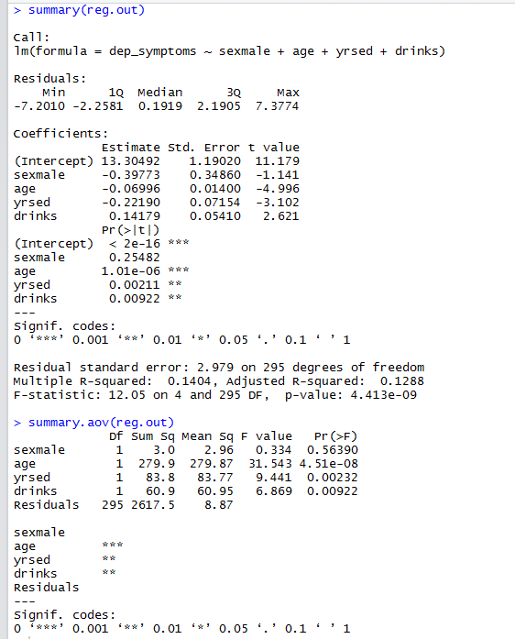
Slopes: 13.30492
Standard Errors: 2.979
P-values: 4.413e-09
R^2=0.1404, that means the 14.04% depressive symptoms can be explained by variables.
From the P-value=4.413e-09 which is smaller than 0.05, we could find there is significant correlation with age, sex, years of education and alcohol consumption for depressive symptoms.
From the graph, we could find as alcohol consumption increase 1, the depressive symptoms will increase 0.14179.
2B. As an alternative way of treating alcohol consumption, we want to include the categorical alcohol consumption variable classifying respondents as abstainers/lighter drinkers/heavier drinkers. As a preliminary step to the analysis, create two dummy variables to represent the three alcohol consumption categories (using variable 9, the categorical alcohol consumption variable as a starting point). Set up the dummy variables so that the abstainers are the reference category.

Using these dummy variables, run a multiple regression predicting depressive symptoms from age, sex, years of education, and the two dummy variables for alcohol consumption.

Present the results of this analysis in a table giving slopes, standard errors, and p-values.

How well does this regression predict depressive symptoms?

Based on this analysis, describe the association between alcohol consumption and depressive symptoms by interpreting the slopes for the alcohol consumption dummy variables in this model.
Answer:
Slopes: 13.44591
Standard Errors: 2.979
P-values: 1.079e-08
From the P-value=1.079e-08 which is smaller than 0.05, we could find there is significant correlation with age, sex, years of education lighter drinkers and heavier drinkers for depressive symptoms.

R^2=0.1431, that means the 14.31% depressive symptoms can be explained by variables.

From the graph, we could find as lighter drinkers increase 1, the depressive symptoms will decrease 0.28337.
From the graph, we could find as heavier drinkers increase 1, the depressive symptoms will increase 1.64234.

2C. (No right answer – won’t be graded) Which of the two models – the model from 2A using alcohol consumption as a continuous variable, or the model from 2B treating alcohol consumption as a categorical variable – do you think is more useful in describing the association between alcohol and depressive symptoms?
Answer:
I think the second would be better. In our life, we cannot control our behavior all the time. There are some persons want to relax and drink a little. The second model will help them to understand the different between the lighter drinkers and the heavier drinkers. If we want to do more surveys in the future, the second model also can help us.

2D. For the dummy variable model in 2B, we would like to give one p-value testing the association between alcohol consumption, represented by the 2 dummy variables, and depressive symptoms, controlling for age, sex, and years of education. Carry out a multiple partial F-test, reporting the F-statistic, degrees of freedom, and p-value.
Answer:
F-test=3.896
Degrees of freedom=294
P-value=0.021
In here, we can find p-value=0.021, smaller than 0.05, we can say there is significant association between alcohol consumption, represented by the 2 dummy variables, and depressive symptoms, controlling for age, sex, and years of education.

3. The goal of this question is to find a prediction interval from a multiple regression model. For the regression from 2A, predicting the depressive symptom score from age, sex, years of education, and the continuous drinks per week alcohol variable, find the prediction depressive symptom score for a 30 year old male college graduate (16 years of education) who does not drink (number of drinks equal 0). Give the 95% prediction interval for this predicted value.
Answer:
> predict(reg.out, data.frame(sexmale=1 , age=30 , yrsed=16 , drinks=0), interval="predict")
fit lwr upr
1 7.257956 1.321646 13.19426

